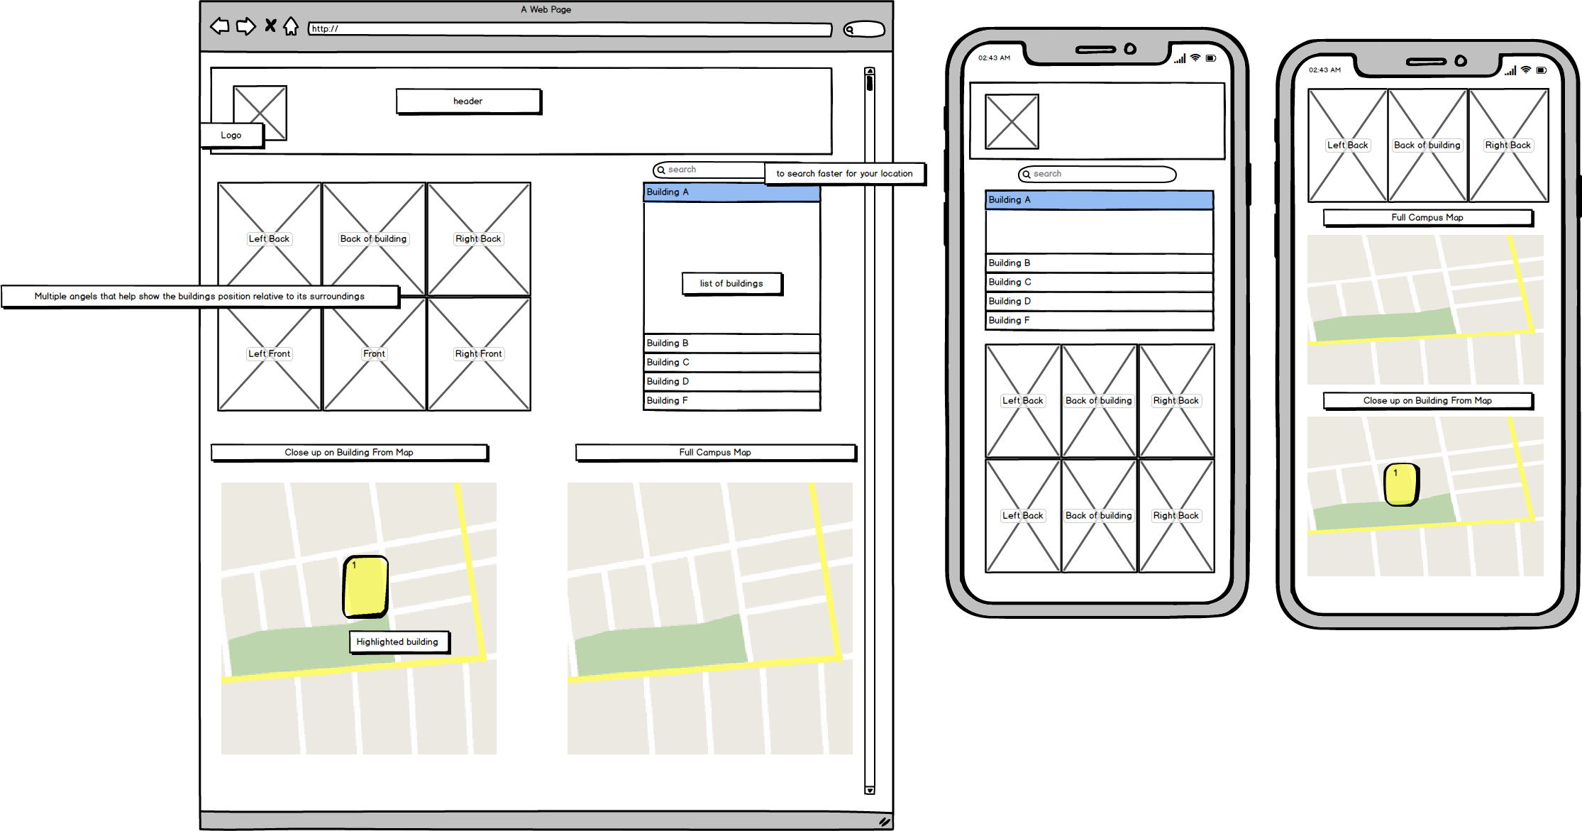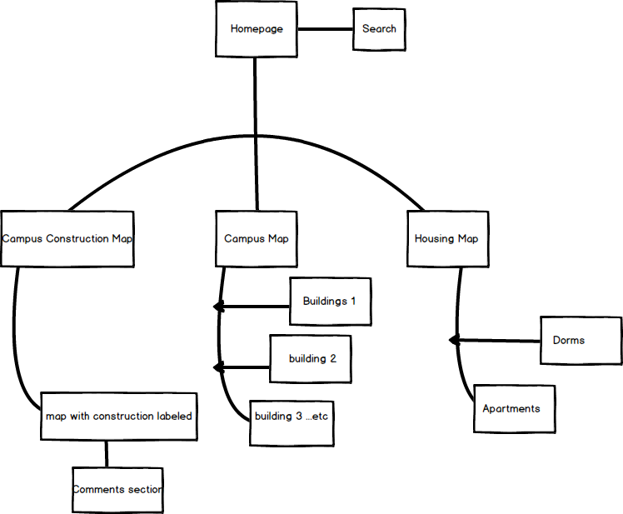

For my webpage I started with the homepage which will have a minimalist design that should allow for the user to fully realize the purpose of the site once they see it. The homepage should have a search bar at the top as well as the three buttons “Campus Construction, Campus Map, Housing”. The search bar will give quick access to students looking for a class by name, bringing the students right to the building page they’re looking for. The Campus Construction Map will highlight roads and areas on the campus map that are undergoing construction, with additional images of the construction too show to show the severity. The Construction map can’t always be kept up to date so ideally, I would add a comments section to the images as a way of notifying the site and its users whether the construction had finished or has made progress. The campus map will have focus on the academic buildings and will have (front, front left, front right, back, back right, back left) images of the building as well as a map of campus with a highlight over the building being searched for. The housing map will help students find their dorms but mainly I want to focus on the apartments, the apartments are a confusing mess and a hassle to find when you’re looking for a friends specific apartment.